Barloworld Integration with Optimizer overview:

Basic landscape is as below. We will only focus in this document on the integration between MMS and Optimizer.

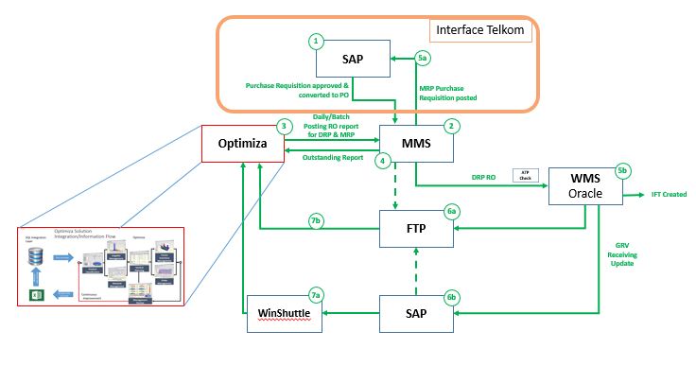

Optimiser is used for planning stock in warehouses, keeping stock levels at the lowest possible while satisfying demand.

In order for Optimizer to be able to do the planning and raise the necessary orders, specific information is required from MMS daily.

**Input to Optimizer:**

The following files are being send from MMS to Optimiza on a daily basis:

|  |  |  |
| --- | --- | --- |
| **File Name** | **Description** | **Used for:** |
| TEL_OPT_OpenIFTExtract | Open IFT orders | Interfacility transfers to move stock from one site to another in order to balance demand |
| TEL_OPT_OpenPOExtract | Open Purchase orders | All open Puchase orders to Vendors that was not yet receipted |
| TEL_OPT_OpenSTOExtract | Open STO (Stock Transfer Orders) | All open STO’s, partially delivered. This is the open qty that cannot be fulfilled from OWMS |
| TEL_OPT_PrevMonthIssuesExtract | All stock issued in the prev month | Article, site and qty details |
| TEL_OPT_StockOnHand | SOH – stock on hand in sites | SOH will only show available stock and not include the stock reserved for STO’s (in progress) |

IFT orders – these orders will be raised by Optimizer when they see that one site is having excess stock of a particular item or the item is a slow mover and can be used in a different site to fullfill demand. As the name suggests it is an Interfacility transfer order to move stock between different sites. Sample file below:

1800|1230|IFT2303223|IT|GRV Partially Complete|2018-05-03 02:07:40 AM|2018-05-03 12:00:00 AM|1003068|1|NDC0000266496|Inserted|2018-05-03 12:00:00 AM|2018-05-03 12:00:00 AM||6.000|6|6.000|0|6|1726687700|6

1800|1230|IFT2303223|IT|GRV Partially Complete|2018-05-03 02:07:40 AM|2018-05-03 12:00:00 AM|1014431|2|NDC0000266496|Inserted|2018-05-03 12:00:00 AM|2018-05-03 12:00:00 AM||1.000|1|1.000|0|1|1726687700|1

Open PO – this is all the suggested PO’s that have been send from Optimizer to SAP which was converted into confirmed vendor purchase orders in SAP. This data shows what still open, awaiting delivery from vendor to site. Sample File below:

1800|1023139|214816|4501733743|2018-05-16 03:32:14 PM|10|5.000|5.00|0||2018-06-21 12:00:00 AM|||Open|Local PO|74404930|2018-05-16 03:32:14 PM|0|||||Malibongwe|1000009310

1800|1024928|214289|4501733725|2018-05-16 03:32:14 PM|10|1.000|1.00|0||2018-09-21 12:00:00 AM|||Open|Repair PO|74404920|2018-05-16 03:32:14 PM|0|||||Malibongwe|2998971

Open STO – This provides all the stock transfer orders from SAP that have not been delivered or is not in the process of delivery. MMS will do an ATP check (call off for the orders) for stock on the specified sites in the order. If there is stock available it will call the order off to the site so the site can start with their outbound delivery process. Once orders are called off, the stock will be reserved for this. Orders can be called off for partial quantities if it conforms to the rule of the article (some articles do not allow partial delivery i.e. kit stock).

The “open STO” file will exclude future dated orders. Future dated is seen as todays date +5. This orders have not been called off yet by MMS to OWMS due to rule on future dated.

Definition of Open STO: ????????

The data provided will be as per the table below:

|  |  |  |  |  |  |  |  |  |  |  |  |  |
| --- | --- | --- | --- | --- | --- | --- | --- | --- | --- | --- | --- | --- |
| Site | Article | Material type | MMS order # | Order date and time | Date and time order was called off | Line number | Order qty | In process qty | Open qty | Status | Ord type | STO # |

Sample of file below:

1210|1011496|674411|70627300|2018-04-16 02:36:06 PM|2018-04-26 12:00:00 AM|30|8.00|6.00|2.00|6.00|2018-04-26 12:00:00 AM||Partially Delivered|PROJ||4803038167|70627300||

1210|1011496|674411|70877540|2018-04-17 02:34:38 PM|2018-04-24 12:00:00 AM|20|1.00|0.00|1.00|0.00|2018-04-24 12:00:00 AM||Not Delivered|PROJ||4803038412|70877540||

Previous month’s issues – This is article data and qty that was issued out by site in the previous month. Sample file below:

1800|442514|4300117367|2018-04-13 12:00:00 AM|10.000|110404|NORM|1|2017-01-25 01:39:55 PM|2017-01-26 12:00:00 AM|0000605900

1430|1024785|4300117551|2018-04-10 12:00:00 AM|3.000|108312|NORM|4|2017-01-26 02:10:22 PM|2017-01-27 12:00:00 AM|0000680140

SOH – Stock On Hand report provide what stock is available for ATP – available to promise. This stock excludes all stock that was reserved for STO’s as well as blocked articles i.e. quarantine. File will contain the site with article and available qty.

|  |  |  |  |
| --- | --- | --- | --- |
| Site | Location | Article | Quantity available |
| 1210 | 1000 | 1000560 | 1 |

1210|1000|1000560||1

1210|1000|1000788||8

1210|1000|1001398||5

**Output from Optimizer:**

Based on the above information Optimiza will use specific algorithms to determine what stock is required and whether this can be done by raising an IFT (part of their DRP) or by sending a suggested purchase order (Part of their MRP) to SAP. If this order is approved in SAP, the PO will be interfaced to MMS and OWMS as well as provided to a vendor to deliver stock to the site specified in the order. (This is a Telkom process and we do not have details on whether this order is emailed or send via EDI to vendor)

In order for the demand planning to be done correctly, the data between SAP and MMS must always be in sync. Special care must be taken to ensure STO’s and PO’s balance to ensure planning is correct.

**Recommendations:**

Cleanse historical data by comparing open STO’s between SAP and MMS. Whatever is not open in SAP (Closed) should be closed in MMS. This will prevent obsolete data to come through to Optimizer which in turn can cause unnecessary DRP planning.

Ensure daily GRV file from OWMS updates orders in SAP as well as MMS. Error log on this must be monitored and managed daily to ensure status on orders are in sync daily.

